TOPIC 1.3 | The Sun

1.3a demonstrate an understanding of how the Sun can be observed safely by amateur astronomers
The safest way and the most recommended way for amateur astronomers to observe the Sun is to use an indirect projection method. In other words a pair of binoculars or a telescope will focus an enlarged image of the Sun onto a screen, reducing the brightness to a safe level.
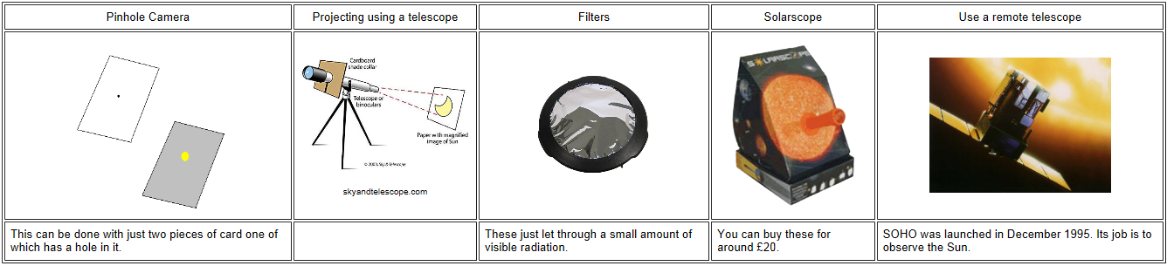

1.3b recall the Sun’s diameter (1.4 million km) and its distance from Earth (150 million km)

1.3c recall the temperature of the Sun’s photosphere (5 800 K)
The photosphere is the outermost part of the Sun that we see; it is made of hydrogen. The average temperature of the photosphere is 5800K.

1.3d describe the solar atmosphere (chromatosphere and corona) and recall the approximate temperature of the corona (2 million K)
The chromosphere (sphere of colour) is a relatively thin part of the Sun's atmosphere (2000km). It is not usually visible as the light from the photosphere is far too dominant. However it can be observed as a reddish/pink ring just before totality has occurred during a solar eclipse.
The corona is a glowing region of ionised gas and has a temperature of 2million K (hot enough to emit X-rays). It can be observed during a total solar eclipse.
Energy is released in the core when hydrogen nuclei are converted to helium during nuclear fusion reactions. The energy generated is radiated away from the core and causes convection currents which carry heat energy up towards the photosphere. The chromosphere and corona form the suns atmosphere.

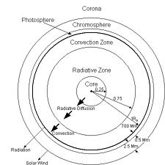

Solar prominences are jets of flaming hydrogen gas that spurt out of the Sun at enormous speeds. They are held in the corona by the Sun’s magnetic field. Some form arcs called loop prominences.
1.3e describe the appearance and explain the nature of sunspots
Sunspots are a temporary spots or patches on the photosphere, and are dark in contrast to their surroundings. They are cooler areas that correspond to strong localised magnetic fields. The magnetic fields inhibit the upward motion of convecting solar material, preventing it from reaching the top of the photosphere, resulting in lower temperatures. Sunspots usually occur in pairs or groups of opposite magnetic polarity (N & S poles).

Sunspots typically consist of
- an umbra, which is the central region that appears to be darker. It is around 2000K cooler than the photosphere.
- A penumbra, the slightly lighter surrounding region. It is about 200K cooler than the photosphere.

1.3f recall that the Sun’s rotation period varies from 25 days at the equator to 36 days at its poles
There is variation in the Sun's rotational period as it does not rotate as a fixed body.

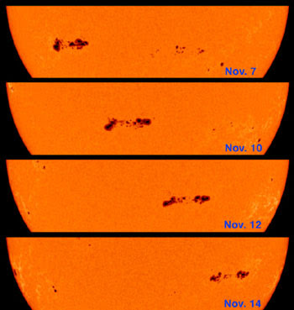
1.3g demonstrate an understanding of how astronomers use observations of sunspots to determine the Sun’s rotation period
The period of rotation of the Sun is determined (calculated) by sunspots. An astronomer may identify a sunspot, or group of sunspots and they will take numerous photographs. They will then look how far the sunspot has moved in that period of time. As sunspots don't always last for too long, an astronomer may have to calculate the rate at which that part of the Sun is rotating and then have to multiply it to find out how long it would have taken for one whole revolution.

1.3h interpret data (e.g. a Butterfly diagram) in order to describe the long-term latitude drift of sunspots, determine the length of the solar cycle and predict the year of the next solar maximum

Fewer sunspots midway between poles and equator
No sunspots
Few sunspots close to equator
Start of cycle many sunspots near the poles

EQUATOR

It takes approximately 11 years for one solar cycle which begins with many sunspots at latitudes close to the poles. As the cycle progresses the sunspots reduce in number and move closer (drift) to the equator. The cycle ends with a period when there is no sunspot activity.
The butterfly diagram shows the position and number of sunspots over a period of time. Draw a line from the start and end of the cycle to the time scale to calculate the solar period.
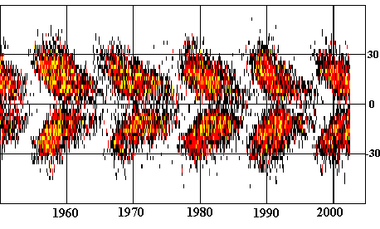

Latitude/º

equator

Time/ years

1.3i demonstrate an understanding that the Sun’s energy is generated by nuclear fusion reactions at its core, converting hydrogen into helium
The Sun's energy is created as a result of nuclear fusion in its core. It is so hot (15 million K) that the hydrogen nuclei fuse together to form helium nuclei. This series of reactions is known as the proton-proton chain.
At each stage of the proton-proton chain, matter is lost and converted into an equivalent amount of energy, according to Einstein’s famous equation, E=mc² where m is matter, E is energy and c is the speed of light.
The Sun losses around 4 tonnes of matter each second as a result of proton-proton chain reactions.
1.3j describe how astronomers observe the Sun at different wavelengths
Light is made up of different wavelengths. The visible spectrum (ROYGBIV) is only a very small part. Different wavelengths can be used to detect the different forms of light which the Sun emits. So, observing the Sun at different wavelengths helps astronomers to build a more comprehensive picture of our local star.
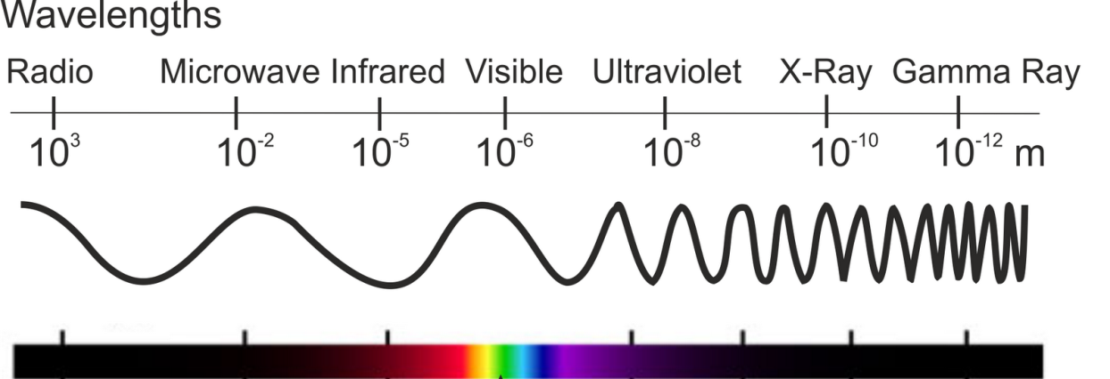

1.3k demonstrate an understanding of the appearance of the Sun at different wavelengths of the electromagnetic spectrum, including visible, H-alpha , X-ray
Astronomers usually observe the Sun using visible and X-ray regions of the spectrum. They also use H-alpha light, a wavelength of 656 nm that is emitted by hot, ionised hydrogen gas.
When a telescope is fitted with H-alpha features, it allows a narrow range of wavelengths to pass through and blocks the remaining light. This increases the contrast, allowing solar features such as prominences, filaments, solar flares, sunspots and the chromosphere to be observed clearly.
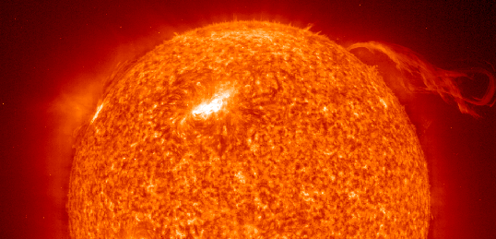
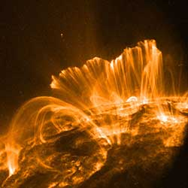
x-ray image

Hydrogen α image

1.3l describe the structure and nature of solar winds
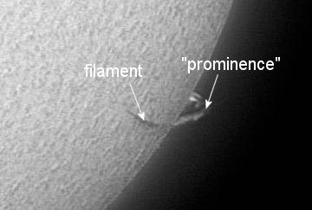
Prominences are huge clouds of cooler gas in the Sun's atmosphere.
Filaments are the same as prominences but they appear as dark silhouettes against the brighter photosphere.

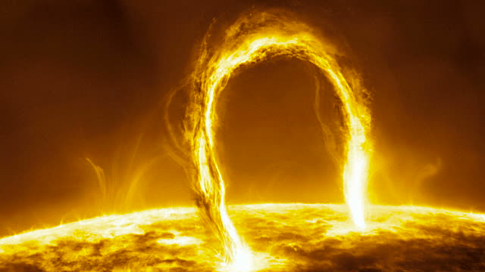
Solar flares are sudden releases of energy from the Sun.

The exceptionally hot regions of the Sun emit X-rays. The bright regions at the edge of the solar disc reveal the Sun's extremely hot corona, and the bright areas on the solar disc are associated with active region loops, where ionised hydrogen flows along curved magnetic field lines.

The solar wind is a steady stream of charged particles flowing outwards in all directions from the Sun's corona.
The high temperature of the corona partially explains how these particles are able to gain sufficient kinetic energy to escape the Sun's pull of gravity.
