

- The NI health care budget for 2010/11 was £9,886.7million. How much of this was spent on treating the medical effects of obesity?

- Why is education in schools so important in tackling obesity problems?

- In 2008 there were 381,100 children (under 16) living in NI. Use the information above to calculate the number of children that would have been diagnosed as obese.
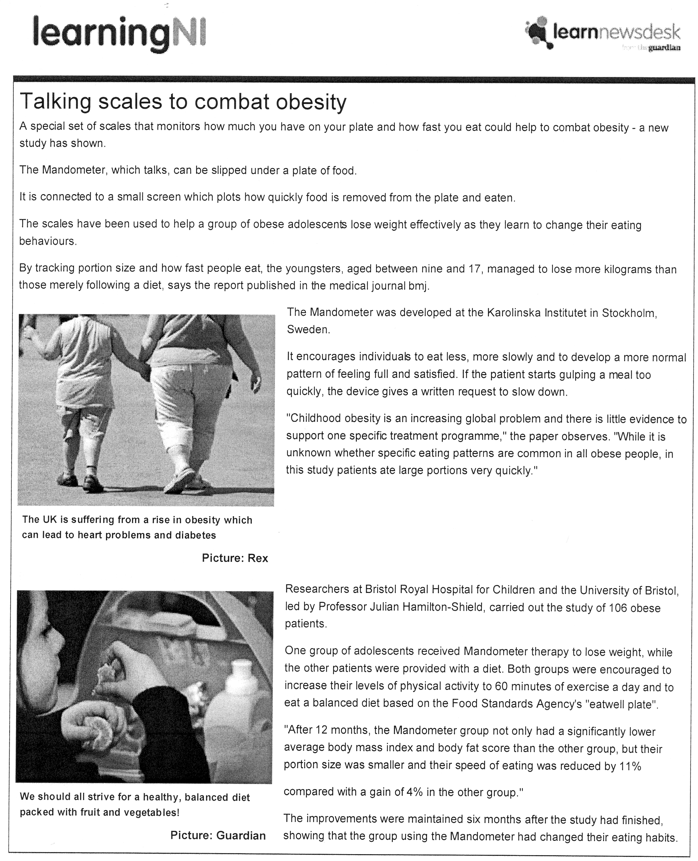

- It is estimated that it takes twenty minutes to feel full once we start eating a meal. How would these scales help someone with obesity to reduce the amount of food that they eat during each meal?

- What is the evidence in the article that the Mandometer helps people with obesity to reduce weight?

- What further measures could be taken as evidence that the Mandometer is effective in changing the eating habits of obese adolescents?

