Chapter 3 Coordination & Control in Plants
1.
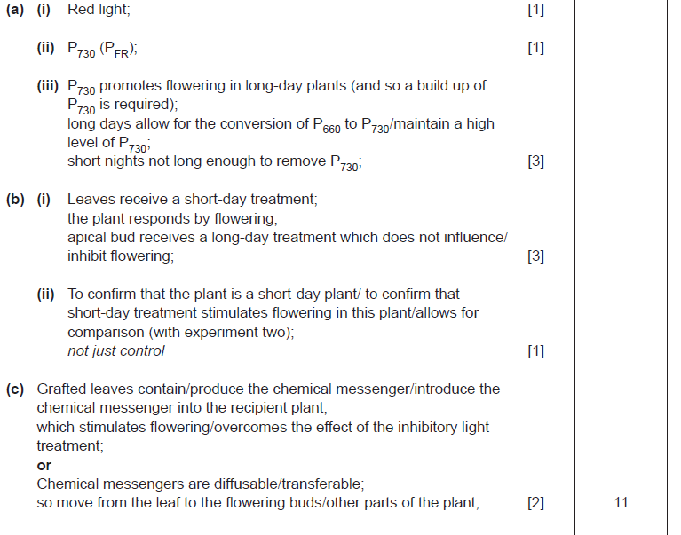
CCEA A21 June 2010 Q7
2.
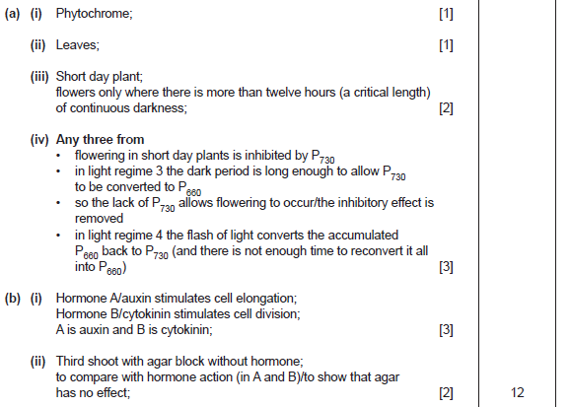
CCEA A21 June 2011 Q5
3.
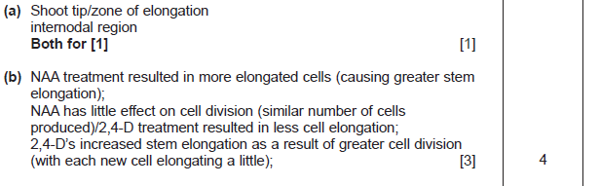
CCEA A21 Jan 2011 Q2

4.
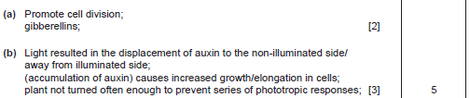
CCEA A21 May 2012 Q1
5.
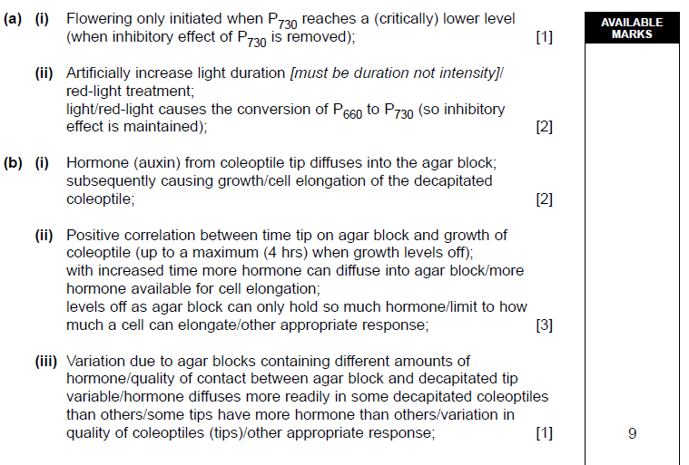
CCEA A21 Jan 2012 Q5
6.
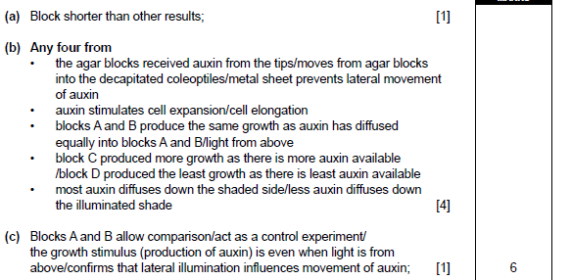

CCEA A21 Jan 2010 Q3

