

Name ___________________________________________________________

LEARNING OUTCOMES
CCEA GCSE BIOLOGY: 1.3.1 - 1.3.10
 | UNIT 1.3 Nutrition and Health
 | LEARNING OUTCOMES | PUPIL SELF-EVALUATION
 | Pupils should be able to: | Good | Average | Requires Attention
1.3.1 | Understand the idea of a balanced diet
 | Describe how to test foods for:
 | ● reducing sugar using Benedict's reagent
 | ● starch using Iodine solution
 | ● amino acids & proteins using Biuret reagent
 | ● fat using ethanol
 | ● Vitamin C using DCPIP
1.3.2 | State the colour changes associated with each reagent:
 | Benedict’s: Blue to Brick red precipitate
 | Iodine: Yellow/Brown to Blue/Black
 | Biuret: Blue to Purple
 | Ethanol: Clear to White emulsion
 | DCPIP: Blue to Pink and then colourless
1.3.3 | Calculate the vitamin C content of vegetable and fruit juices, (natural, processed and boiled) by comparing quantitatively to a standard solution of ascorbic acid (vitamin C)
1.3.4 | Know the principal elements present in carbohydrates, fats and proteins.
 | Know the sources and functions of:
 | ● simple carbohydrates (sugars, glucose and lactose);
 | ● complex carbohydrates (cellulose, glycogen and starch);
 | ● fats (fatty acids and glycerol);
 | ● proteins (amino acids);
 | ● vitamins C and D (deficiency symptoms);
 | ● minerals (iron and calcium and their deficiency symptoms)
 | ● fibre;
 | ● water;
1.3.5 Y11 | Calculate the energy content of food by burning food samples,
 | Compare their data with data from food labels,
 | Evaluating the methods of data collection and their reliability and validity
1.3.6 | Use secondary data to calculate BMI and BMR rates,
Y11 | Work out recommended daily energy intake using the Harris–Benedict mathematical model
1.3.7 Y11 | Explain why energy requirements vary with age, gender, activity levels and pregnancy
1.3.8 | Understand how human health is affected by:
Y11 | ● inherited factors;
 | ● environmental factors – obesity can be caused by energy intake being higher than energy used in exercise
 | ● healthy food choices – limited intake of sugar, salt and fat and the benefit of fruit and vegetables
1.3.9 Y11 | Understand the contribution of an unhealthy diet to obesity, heart disease, strokes, high blood pressure, diabetes and arthritis
1.3.10 Y11 | Understand the costs to society of the current trend in obesity levels, including economic cost of treatment for NHS

Terminology
simple carbohydrate, reducing sugar, glucose, lactose, Benedict's, complex carbohydrate, cellulose, glycogen, starch, iodine, amino acid, protein, Biuret reagent, fat, fatty acids, glycerol, ethanol, Vitamin C, DCPIP, Vitamin D, Mineral, iron, calcium, deficiency disease, fibre, water, carbon, hydrogen, oxygen, nitrogen, ascorbic acid, graduated cylinder, compare, evaluate, reliability, validity, BMI, BMR, inherited factors, environmental factors, healthy choices, obesity, heart disease, stroke, high blood pressure, diabetes, arthritis, economic cost to society
UNIT TEST RESULT: % GRADE:
PUPIL COMMENT

Functions of food
Energy, growth, protection

A balanced diet
Requires the correct food groups in the correct amounts. These include:
carbohydrates, fats, proteins, vitamins, minerals, water

Starvation occurs when a person does not get enough food to eat so that the body is using more energy than the diet is supplying.
Malnutrition occurs when the correct quantity of food is eaten but it is a poor balance e.g. it may consist of only one food type.

The types of foods we eat can be divided into 7 groups: carbohydrates, fats, proteins, vitamins, minerals, fibre and water. Each food group has a specific function in the body.

FIBRE
Where we get it cellulose cell walls of plants, that we cannot digest e.g. cereals, fruit & veg
What it is used for: helps food to keep moving through the digestive system
What happens if it is deficient: constipation, bowel cancer
Water
Where we get it: food and drink we ingest
What it is used for:
- transport in the blood,
- as a component of the cytoplasm and body fluids,
- as a solvent in our cells,
- to regulate body temperature,
- excretion (sweat / urine),
- chemical reactions in cells

The tables on the next pages summarise information about the remaining nutrients.

USE IN THE BODY | Energy release |  | Energy storage in animals | Energy storage in plants | fibre | insulation, protection, energy storage |  | Growth  & repair
FOODS HIGH IN THIS GROUP | jam, biscuits, fizzy drinks | milk & dairy products | we make it in liver  & muscle cells from glucose | bread, pasta, rice | fruit and vegetables | butter | olive oil | Eggs, meat, fish | Nuts, pulses
INCLUDES | glucose | lactose | glycogen | starch | cellulose | Animal fats | Plant fats | Animal protein | Plant protein
INCLUDES | SIMPLE  CARBOHYDRATES |  |  | COMPLEX CARBOHYDRATES
MADE UP OF | sugars |  |  |  |  | glycerol, & fatty acids |  | amino acids
CONTAINS THE ELEMENTS | Carbon,  Hydrogen,  Oxygen  (C, H, O) |  |  |  |  | Carbon,  Hydrogen,  Oxygen  (C, H, O) |  | Carbon,  Hydrogen,  Oxygen, Nitrogen  (C, H, O, N)
FOOD GROUPS | CARBOHYDRATES |  |  |  |  | FATS |  | PROTEINS

DEFICIENCY DISEASE | SCURVY (sore gums and bleeding around bones and from the intestine) | RICKETS (soft bones that bend and dental decay) | poor  development of  bones and teeth | ANAEMIA chronic fatigue because there is less haemoglobin to carry oxygen, which is needed for respiration to release energy
FUNCTION | maintain blood vessels  &  development of teeth and gums | regulates the use of calcium and phosphorus for making bones and teeth | make bones and teeth | haemoglobin in red blood cells
FOODS HIGH IN THIS GROUP | fresh vegetables & citrus fruit | fish liver oil, liver, milk, eggs | milk & dairy products | red meat
FOOD GROUP | VITAMIN C | VITAMIN D | MINERAL: CALCIUM | MINERAL: IRON

Food tests

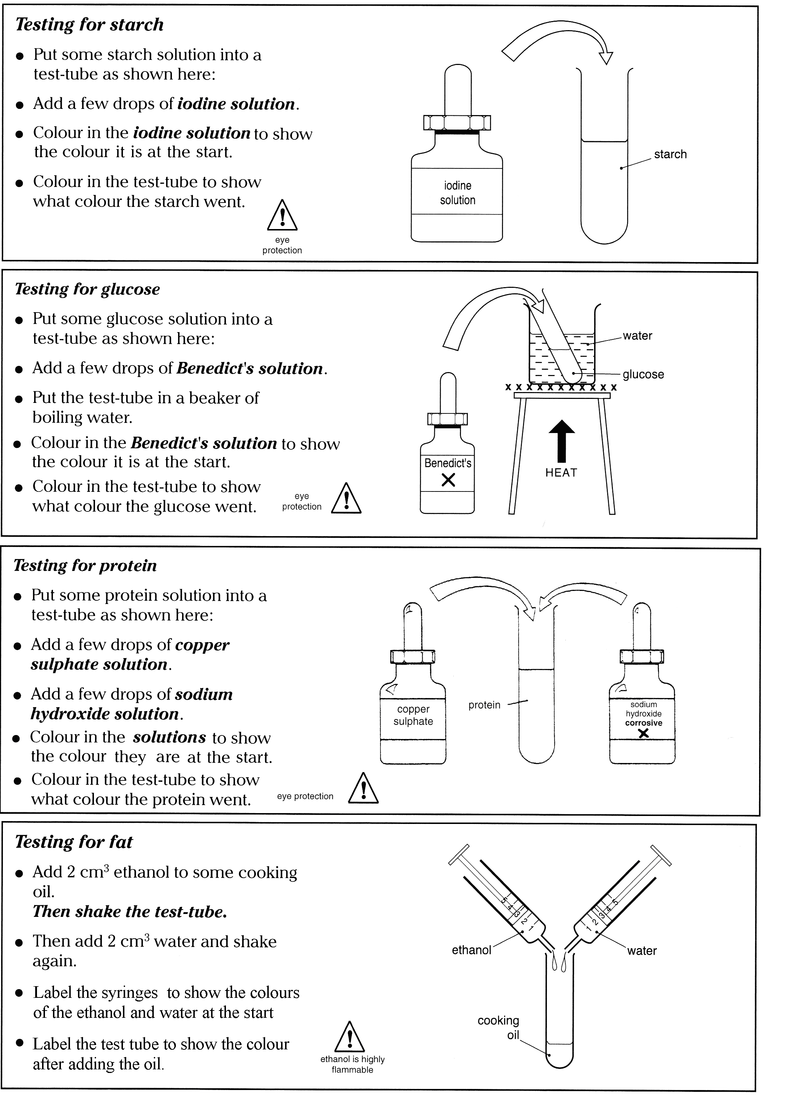

BIURET TEST

CLUEDO

TABLE OF RESULTS

conclusion
____________________________________________________________________________ ____________________________________________________________________________ ____________________________________________________________________________ ____________________________________________________________________________ ____________________________________________________________________________
____________________________________________________________________________ ____________________________________________________________________________ ____________________________________________________________________________ ____________________________________________________________________________ ____________________________________________________________________________

QUESTIONS

- Choose the correct word/s to complete the sentences about food.
  - Sugar is needed for (roughage / energy) and is found in (meat / cakes)
  - Fat is needed for (growth and repair / insulation) and is found in (bread /butter)
  - Protein is needed for (growth and repair / insulation) and is found in (meat / toffee)

- Complete the sentences:
  - Starch consists of smaller units called ________________________________
  - Protein consists of smaller units called _______________________________
  - Fats consists of smaller units called _________________________________

- Tick the elements found in each of the food groups.
FOOD GROUP | CARBON | HYDROGEN | OXYGEN | NITROGEN
CARBOHYDRATE
PROTEIN
FAT

- Complete the following table about food tests:

 | SUGAR | STARCH | PROTEIN | FAT
INDICATOR
IS HEAT REQUIRED?
COLOUR OF
POSITIVE TEST

- A pupil was given powders A, B, C, D and E. Each powder was tested for the presence of Glucose, starch and protein. The table shows the final colour observed at the end of each of the tests.

 | A | B | C | D | E
BENEDICT’S TEST | Orange | Blue | Blue | Orange | Blue
IODINE TEST | Black | Black | Yellow/brown | Black | Yellow/brown
BIURET TEST | Blue | Blue | Purple | Purple | blue

Which powder contained:
- Protein only? __________________________
- Starch only? __________________________
- Starch and glucose only? __________________________
- Glucose, starch and protein? __________________________
- None of these substances? __________________________

- Fibre is an important part of a healthy diet. The fibre content of some vegetables is given in the table below.

Vegetable | Brussel  sprouts | Peas | Spinach | Carrots | Sweetcorn | Beans
Fibre content % | 2 | 52 | 63 | 26 | 40 | 15

  - Draw a bar graph to show the fibre content of each of the different vegetables.



  - Some vegetables are better sources of dietary fibre than others.
Which have a fibre content greater than 30%? _______________________
  - Calculate the ratio of fibre in peas to that in carrots

Ratio _____________________ : __________________________
Fibre in peas fibre in carrots

  - Calculate the number of grammes of fibre present in a 50g portion of sweetcorn.

________________ g

ESTIMATING HOW MUCH VITAMIN C IS IN ORANGE JUICE

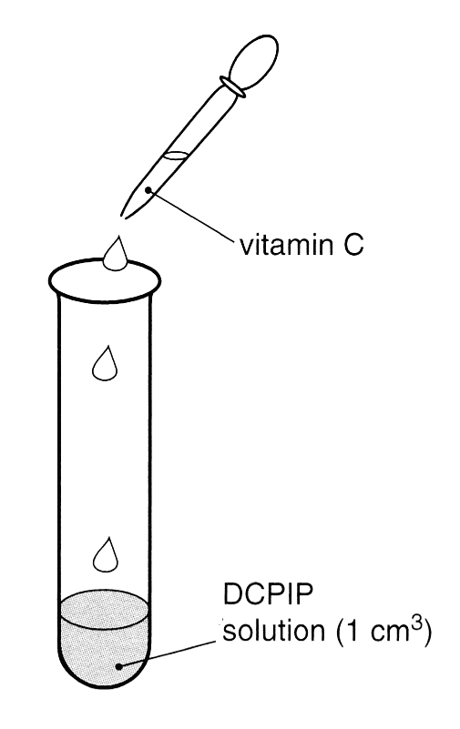
The indicator DCPIP is used to test for the presence of vitamin C.
Vitamin C turns blue DCPIP colourless.

Juice with lots of vitamin C will take few drops
to change the blue DCPIP to colourless.
Juice with little vitamin C will take more drops
to change the blue DCPIP to colourless.

Ascorbic acid is the chemical name for vitamin C.
If the volume of fruit juice needed to decolourise the DCPIP is
greater than the volume of 0.1% ascorbic acid, then the juice
contains less than 0.1% vitamin C.

Count how many drops of each juice it takes to make the blue colour go and write the results in the table below.

Test tube | 1 | 2 | 3 | 4 | 5
Type of  orange juice | Freshly squeezed | Fresh carton | Unfresh  carton | Heated  carton | 0.1% ascorbic  acid
Volume  of DCPIP / cm³ | 1 | 1 | 1 | 1 | 1
Number of drops
of juice needed
to turn the
blue DCPIP
colourless

Which orange juice has the most vitamin C? __________________________________
Which orange juice has the least vitamin C? __________________________________
Which orange juice/s contain/s more than 0.1% vitamin C?
___________________________________________________________________________
How does heating affect the amount of vitamin C? __________________________________
___________________________________________________________________________
Why is it a good idea to drink carton juice within a few days of opening?
________________________________________________________________________________________________________________________________________________________
Why do you think that there is often more vitamin C in carton juice than there is in freshly squeezed orange juice?
________________________________________________________________________________________________________________________________________________________
Name one other factor that could affect the vitamin C content of fruit drinks?
____________________________________________________________________________

Investigations

The things that can be changed during an investigation are called factors or variables.
In a fair test only one variable is changed, all others remain the same.

There are 3 types of variables in an investigation, independent variable, dependent variable and controlled variables.

Independent variable this is the variable that is changed during an investigation.
What was the independent variable in the Vitamin C investigation?
________________________________________________________________________________

Dependent variable this is the variable that you measure during an investigation.
What was the dependent variable in the Vitamin C investigation?
________________________________________________________________________________

Controlled variables these are the variables that you keep the same during an investigation.
What were the controlled variables in the Vitamin C investigation?
________________________________________________________________________________
________________________________________________________________________________
________________________________________________________________________________

Reliability is about being able to trust your results. It is important to repeat investigations to see if results are reliable. Reliable data will be of a similar size, when repeated.
Discuss the reliability of the class results for the Vitamin C investigation.
________________________________________________________________________________
________________________________________________________________________________
________________________________________________________________________________

Results that are far away from the others are called anomalous results.
Were there any anomalous results in the Vitamin C investigation?
__________________________________________________________________________________________________________________________________________________________________
Accuracy is about measuring precisely.
How could the results in the Vitamin C investigation be made more accurate?
__________________________________________________________________________________________________________________________________________________________________
Validity. Results will not be valid if something cannot be controlled as it may affect the results. What could be done to improve the validity of the results in the Vitamin C investigation?
__________________________________________________________________________________________________________________________________________________________________
__________________________________________________________________________________________________________________________________________________________________
________________________________________________________________________________________________________________________________________________________

Finding the Energy Content of Food

A good indication of the energy content of food can be obtained by burning a dry sample of food. The energy released is used to heat a known volume of water, and from the temperature rise the amount of energy released can be calculated.

BT in clamp

Thermometer
Boiling tube

25cm³ water

Mounted needle
FOOD

Method
1. Draw a table for your results.
2. Measure 25cm³ water into a boiling tube using a measuring cylinder.
3. Measure and record the temperature of the water.
4. Weigh the sample of food and record this in your table.
5. Heat the food sample in a blue Bunsen burner flame until it begins to burn, then hold it under the tube of water, as shown in the diagram above.
6. When the food has burned fully, measure the temperature of the water sample again and calculate the rise in temperature.

Conclusion
1. Calculate the energy given off by the food using the equation below:

ENERGY (J) = mass of water (g) X 4.2 X Temperature Rise

NB. Water has a density of 1g/cm³, therefore 25cm³ water weighs 25g.

2. Calculate the energy in 100g of the food and compare this to the energy

3. List the possible explanations for any differences between these two values.

________________________________________________________________________________________________________________________________________________________________________________________________________________________________________________________________________________________________________________________________________________________________________________________________________________________________________________________________________
____________________________________________________________________________________________________________________________________________________________________________________________________________________________________
____________________________________________________________________________________________________________________________________________________________________________________________________________________________________
____________________________________________________________________________________________________________________________________________________________________________________________________________________________________
________________________________________________________________________________________________________________________________________________________________________________________________________________________________________________________________________________________________________________________________________________________________________________________________________________________________________________________________________

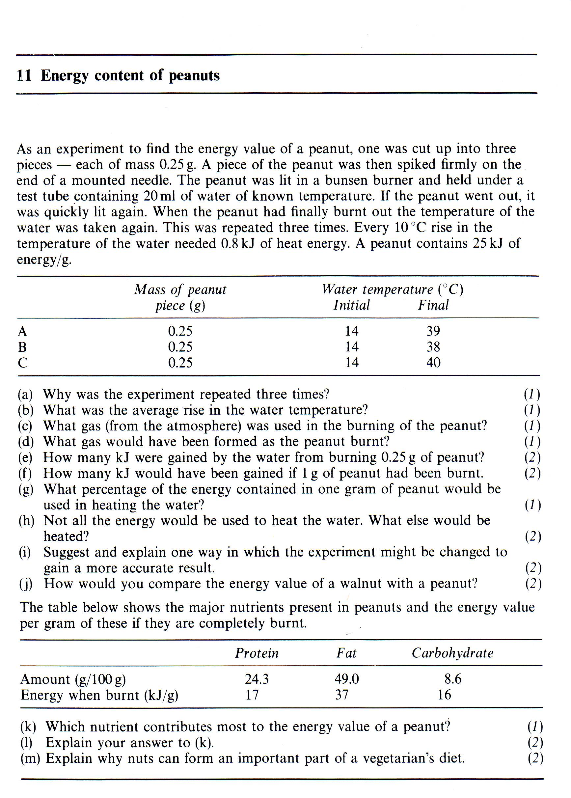

________________________________________________________________________________________________________________________________________________________________________________________________________________________________________________________________________________________________________________________________________________________________________________________________________________________________________________________________________________________________________________________________________________________________________________________________________________________________________________________________________________________________________________________________________________________________________________________________________________________________________________________________________________________________________________________________________________________________________________________________________________________________________________________________________________________________________________________________________________________________________________________________________________________________________________________________________________________________________________________________________________________________________________________________________________________________________________________________________________________________________________________________________________________________________________________________________________________________________________________________________________________________________________________________________________________________________________________________________________________________________________________________________________________________________________________________________________________________________________________________________________________________________________________________________________________________________________________________________________________________________________________________________________________________________________________________________________________________________________________________________________________________________________________________________________________________________________________________________________________________________________________________________________________________________________________________________________________________________________________________________________________________________________________________________________________________________________________________________________________________________________________________________________________________________________________________________________________________________________________________________________________________________________________________________________________________________________________________________________________________________________________________________________________________________________________________________________________________________________________________________________________________________
How much energy do we need?

In science energy is measured in the following units:
joules (J); kilojoules (kJ); megajoules (mJ)

However, most food packets also measure energy in calories.

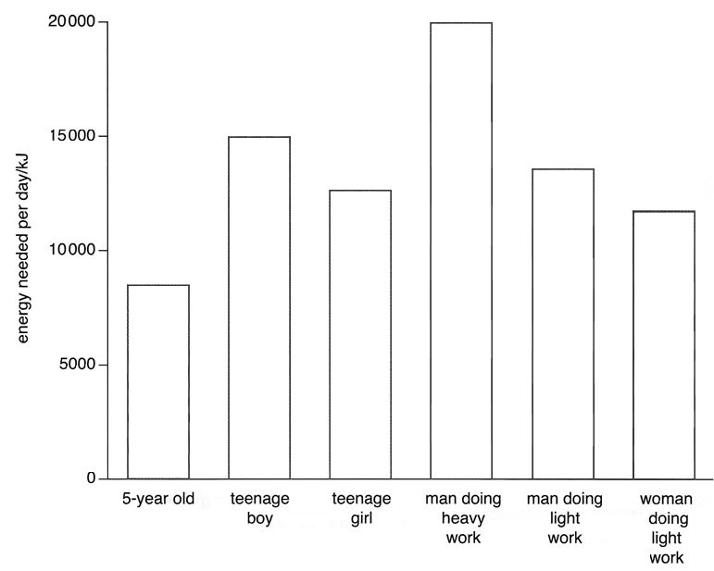

The graph above shows the energy needed by different people in different situations. It shows that there are 3 main factors that affect our energy requirements, and
therefore how much and what we need to eat.
AGE: older people need less energy than younger people as they are growing less
GENDER: generally men have more muscle than women which uses more energy
ACTIVITY: a physically demanding activity requires more energy than a restful one

The extra energy is obtained from meals containing lots of carbohydrates. These are broken down in respiration to release energy.

Pregnant women have high energy and protein needs due to the high rate of growth of the developing foetus. They need to eat more calcium for the growth of bones and more iron for the production of red blood cells.
Nursing or breastfeeding mothers also need extra protein & fluid to make milk.

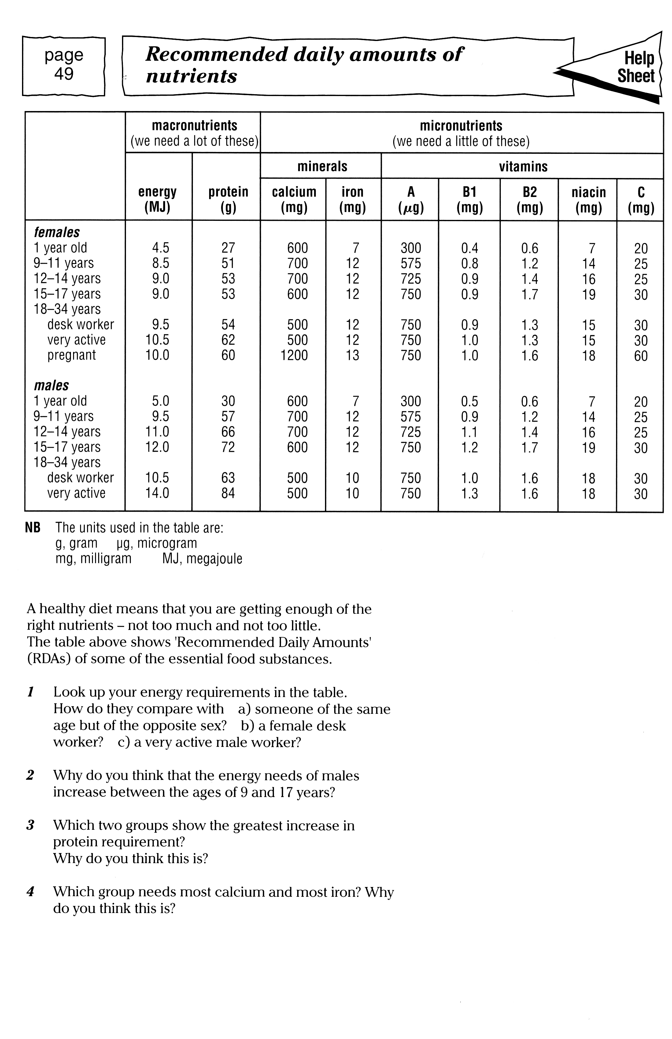

Weight & height

Comparing a person’s height to their weight can be used to determine whether they need to gain, maintain or lose weight. This is a simple way of considering how healthy someone is. The graph below can be used to show the desirable weight range for men and women over 18 years old.

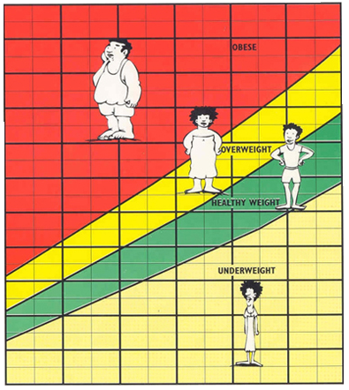
WEIGHT FOR HEIGHT CHART
FOR MEN AND WOMEN FROM 18 YEARS AND OVER
30
40
50
60
70
80
90
100
110
120
130
140
WEIGHT IN LIGHT CLOTHING AND BARE FEET /Kg
HEIGHT in bare feet /cm
140
150
160
170
180
190
140 150 160 170 180 190 200

What advice would you give to a person who is 180cm tall and weighs 100Kg?
______________________________________________________________________________________________________________________________________________________________________
___________________________________________________________________________________

BMI: body mass index

It is now more common to measure a person’s BMI when considering their health.

BMI is a measure of measure of whether someone is the correct weight for their height.
BMI is calculated using the following equation:
BMI = weight
height ²

Weight is always measured in kg and height in m when calculating BMI.

Using BMI values
BMI value | Description
Under 18.5 | Underweight
18.5 – 24.9 | Normal
25 – 29.9 | Overweight
30+ | Obese

Calculate the BMI for a person who is 166cm tall and weighs 46kg.
What does this value mean?

Athletes have very high BMIs, but are not overweight. This is because they have a very high proportion of muscle, which is heavier than fat.

Basal metabolic rate (BMR)
This is a measure of the minimum energy use.
Weight /kg, height /cm, age and gender are required to calculate BMR. It can be calculated using an online calculator or using an equation. The equation to find the BMR for a woman is:

BMR (WOMAN) = 655 + (9.6 X weight) + (1.8 X height) – (4.7 X age)

Calculate the BMR for a 14 year old girls with a mass of 40kg and height of 160cm.

Harris-Benedict equation
The Harris-Benedict Equation uses the BMR value to calculate how much energy you need, to stay at your current weight.
The equation to find the energy needed is:
Energy in joules = BMR X Activity factor

The activity factor is found from a table in text books or the internet; choose the factor which best suits you.

The 14 year old girl in the question above has a BMR of _____________________________________________
Activity factor | Category
1.2 | Minimal exercise
1.375 | Lightly active
1.55 | Moderately active
1.725 | Very active
1.9 | Extremely active
She is very active, playing netball and hockey for the school teams, so she practises every day.
Chose the activity factor: _______________________
Calculate the energy she needs each day:

ANSWER ______________________________________ J

Health & diet

A number of factors affect our health and may lead to disease. The factors can be divided into 3 groups:

Dietary e.g eating too much saturated fat, sugar or salt and eating too little fruit and vegetables can
Environmental e.g. stress
Hereditary the genes you inherit from your parents can make you more susceptible to certain diseases such as heart disease
It is possible to control diet and environmental factors, and so reduce the chance of getting these diseases.
Whilst it is not possible to control the genes you inherit, by controlling the effects of diet and environmental factors you are reducing the chance of getting these diseases to a minimum.

DIETARY DISEASES
DISEASE | CAUSE | EFFECT
OBESITY

HIGH BLOOD
PRESSURE

CORONARY
HEART
DISEASE (CHD)

STROKES

TYPE 2 DIABTES

ARTHRITIS

Costs to society
The number of people with obesity has doubled over the past 20 years to 20% of the population. The NHS is paying more to treat people for obesity and for the medical conditions associated with obesity such as type 2 diabetes and heart disease.
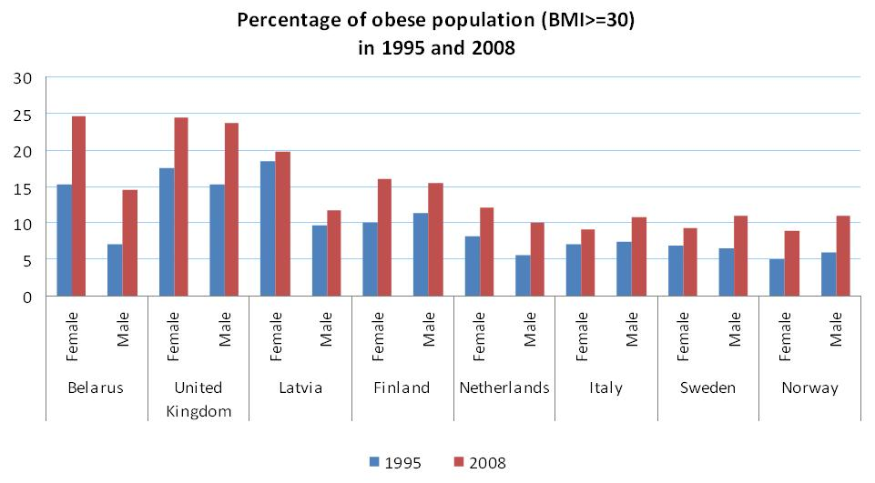

Describe the trends in the data above.
- _________________________________________________________________________________________________________________________________________________________________________________________________________________________________
- _____________________________________________________________________________________________________________________________________________________
___________________________________________________________________________
- ______________________________________________________________________________________________________________________________________________________________
__________________________________________________________________________________

The number of patients diagnosed with dietary related diseases in
Northern Ireland between 2006 and 2013

Disease | 2006/7 | 2007/8 | 2008/9 | 2009/10 | 2010/11 | 2011/12 | 2012/13
OBESITY | 144 945 | 161 871 | 165 956 | 174 180 | 170 840 | 167 150 | 168 976
CHD | 76 126 | 75 984 | 75 278 | 75 123 | 75 027 | 74 788 | 74 648
STROKE | 29 376 | 30 210 | 31 063 | 31 947 | 32 988 | 33 842 | 33 470
High BP | 211 382 | 218 184 | 225 093 | 231 939 | 237 834 | 241 783 | 245 730
Type 2  DIABETES | 56 924 | 60 822 | 65 066 | 68 980 | 72 693 | 75 837 | 79 072

Discuss the results.
___________________________________________________________________________________________________________________________________________________________________________________________________________________________________________________________________________________________________________________________________________________________________________________________________________________________________________________________________________________________________________________________________________________________________________________________________________________________________________________________________________________________________________________________________________________________________________________________________________________________________________________________________________________________________________________________________________________________________________________________________________________________________________________________________________________________________________________________________________________________________________________________________________________________________________________________________________________________________________________________________________________________________________________________________________________________________________________________________________________________________________________________________________________________________________________________________

PAST PAPER QUESTIONS

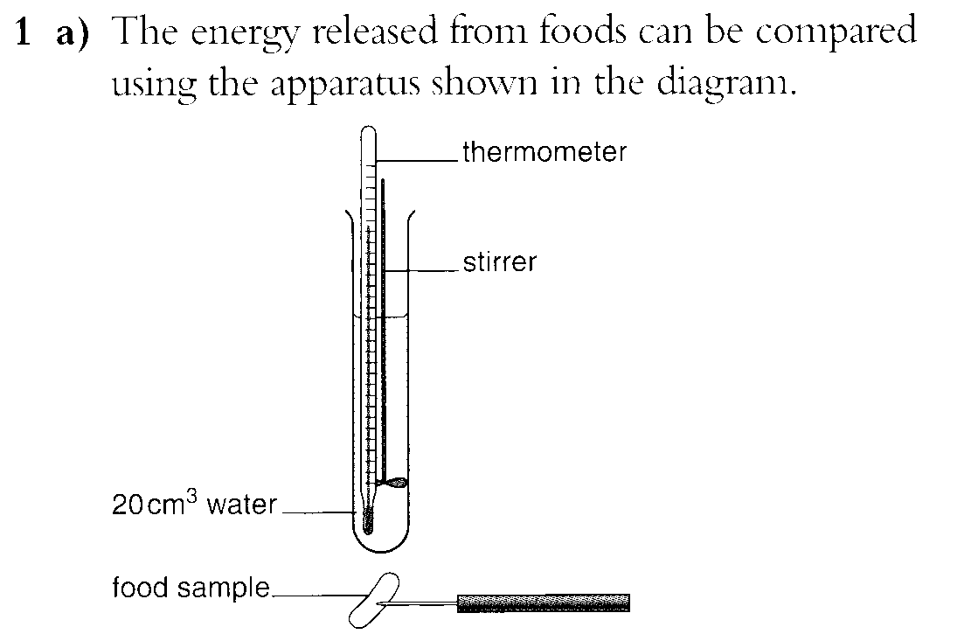
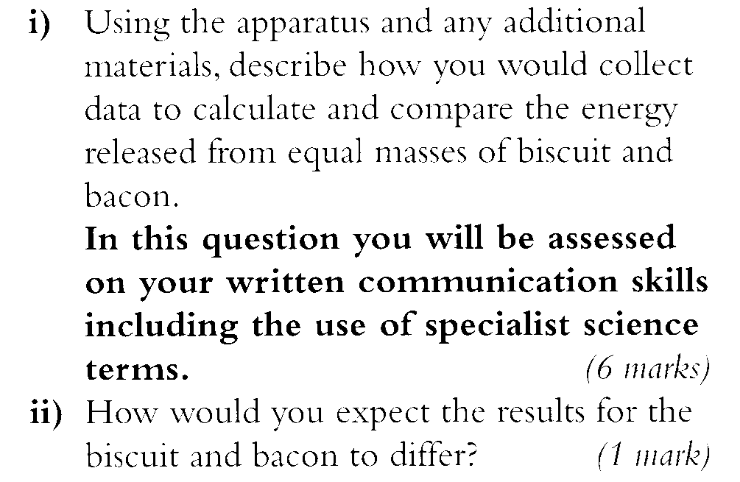

_____________________________________________________________________________________________________________________________________________________________________________________________________________________
_____________________________________________________________________________________________________________________________________________________________________________________________________________________
_____________________________________________________________________________________________________________________________________________________________________________________________________________________
_____________________________________________________________________________________________________________________________________________________________________________________________________________________
_____________________________________________________________________________________________________________________________________________________________________________________________________________________
_____________________________________________________________________________________________________________________________________________________________________________________________________________________
_____________________________________________________________________________________________________________________________________________________________________________________________________________________
_____________________________________________________________________________________________________________________________________________________________________________________________________________________

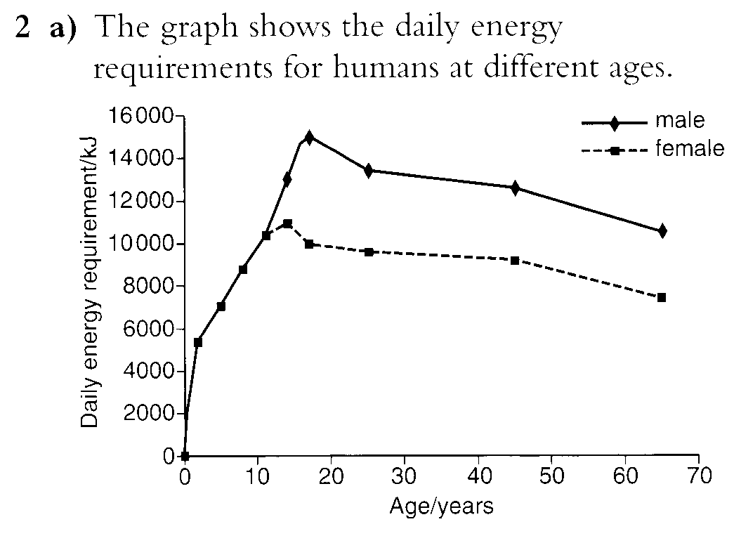
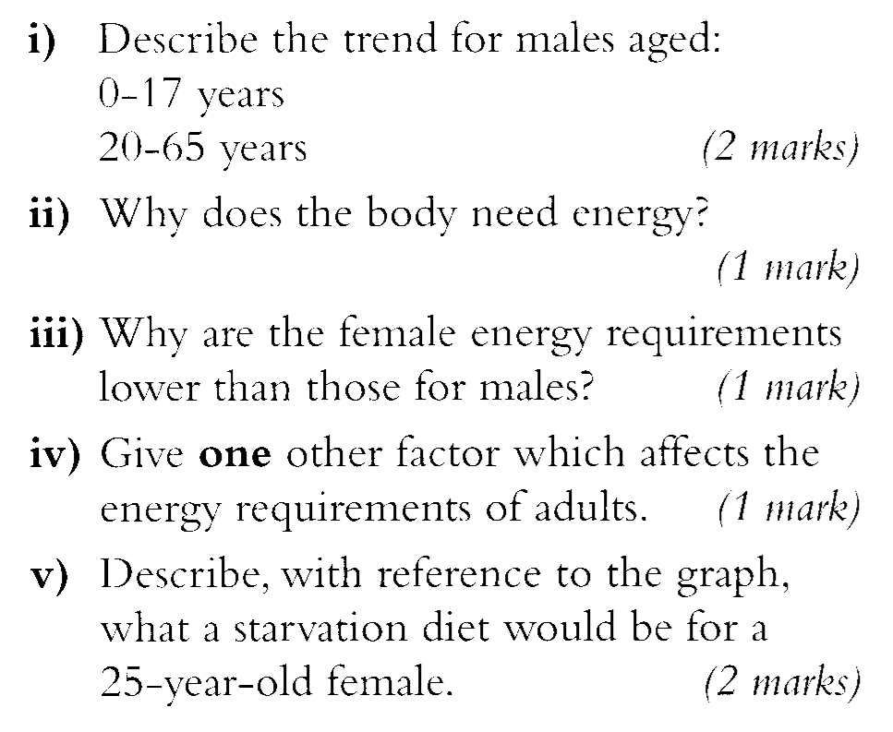

______________________________________________________________________________________________________________________________________________
_____________________________________________________________________________________________________________________________________________________________________________________________________________________
______________________________________________________________________________________________________________________________________________
_____________________________________________________________________________________________________________________________________________________________________________________________________________________
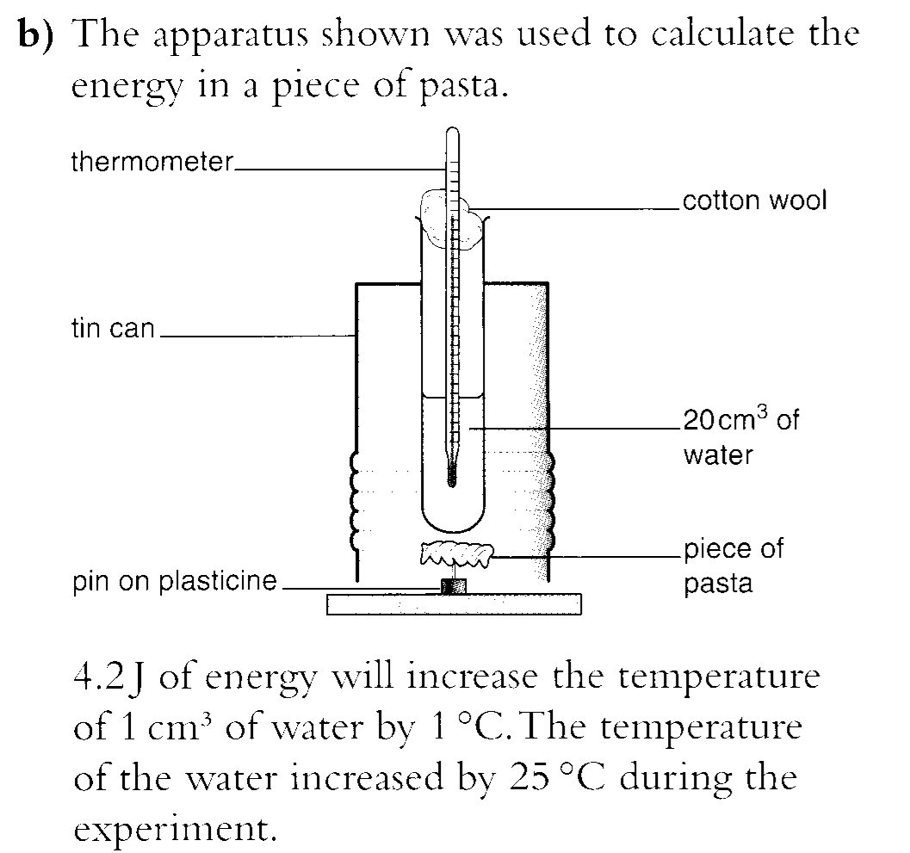
____________________________________________________________________________________________________________________________________________________
______________________________________________________________________________________________________________________________________________________________________________________________________________________________
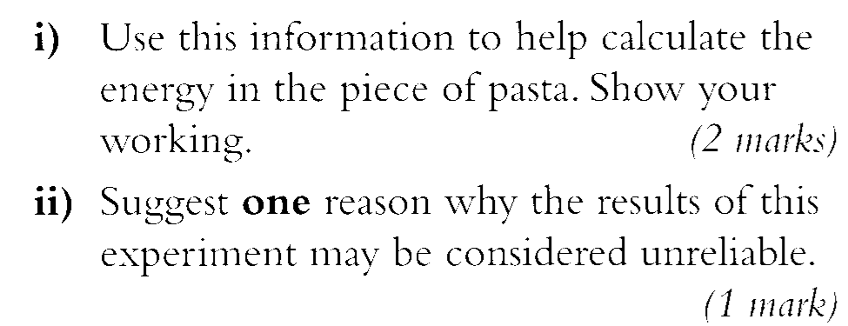
____________________________________________________________________________________________________________________________________________________
_____________________________________

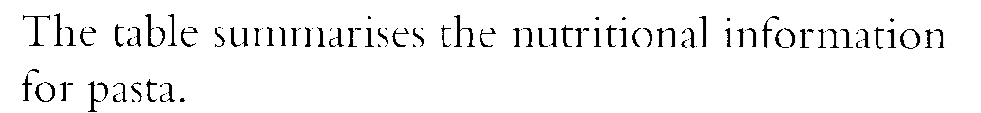
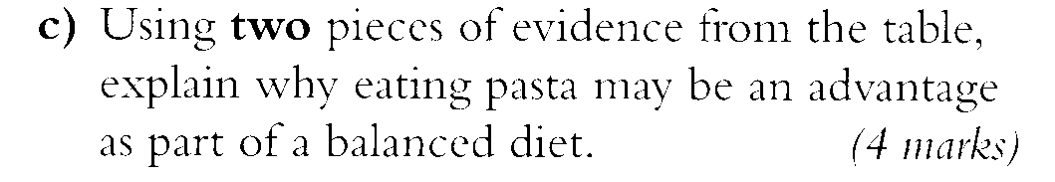

____________________________________________________________________________________________________________________________________________________________
 | Per 100g | Percentage of daily requirement
Energy | 1515kJ | 19.1
Protein | 12.3g
Carbohydrate  Starch | 74.0g  69.6g | 25.0
Fat  Cholesterol | 1.0g  0.0g | 2.0  0.0
Fibre | 3.0g | 2.0
Salt | Less than 0.1g | 1.7
Calcium | 18.0mg | 2.0
Iron | 1.0mg | 6.0
______________________________________________________________________________
______________________________________________________________________________
______________________________________________________________________________
































