IMMUNOLOGY
1.
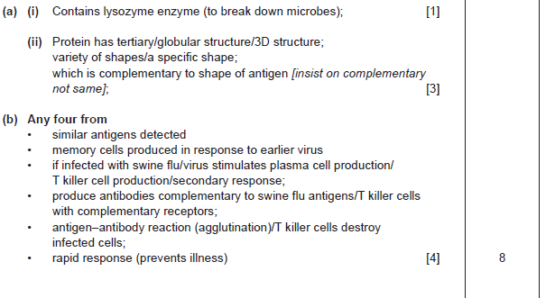
A2 MODULE 1 JUNE 2011 q7
2.
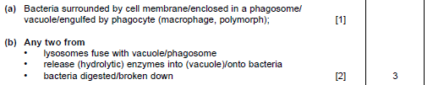
A2 MODULE 1 JANUARY 2012 q1
3.
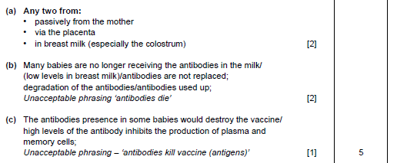
A2 MODULE 1 JANUARY 2010 q2

4.
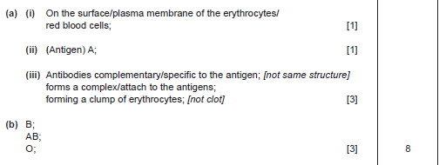
A2 MODULE 1 JUNE 2010 q1
5.
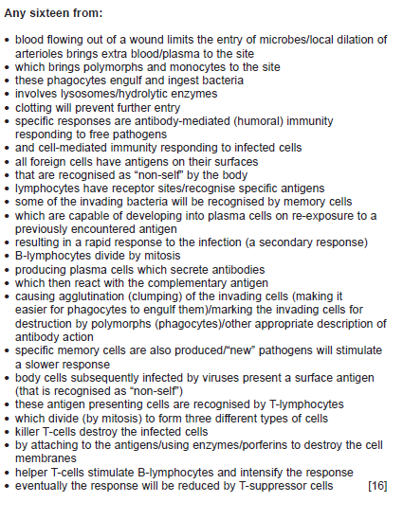
A2 MODULE 1 JANUARY 2011 q9

