

Name ______________________________________________________________

 | LEARNING OUTCOMES
 | CCEA GCSE BIOLOGY: 1.1.1 - 1.1.10
 | UNIT 1: Cells, Living Processes and Biodiversity
 | LEARNING OUTCOMES | PUPIL SELF-EVALUATION
 | Pupils should be able to: | Good |  | Average |  | Requires Attention
1.1.1 | Use a light microscope to examine and identify the structure of plant and animal cells
 | Prepare microscope slides to view onion epidermal cells
1.1.2 | Know the relationship between measurements of length to include metres, millimetres and micrometres
 | Calculate the actual size of a specimen
 | Calculate magnification using a scale bar
1.1.3 | Know the structure and function of animal cells, to include nucleus and chromosomes, cytoplasm, and cell and nuclear membranes
1.1.4 | Know that plant cells have additional structures not found
 | in animal cells: cellulose cell wall, large permanent
 | vacuole and chloroplasts
1.1.5 | Compare and contrast the structure of bacterial cells with plant and animal cells: non-cellulose cell wall, absence of nucleus and presence of plasmids
1.1.6 | Know that multi-celled organisms’ cells are organised to form specialised tissues, organs and organ systems to improve exchange with the environment,
 | to transport substances and to communicate between cells
1.1.7 | Compare and contrast the patterns of growth and development in plant and animal cells:
 | animals grow all over and plants grow at apices to produce a branching pattern
1.1.8 | Describe the origin of animal cells from stem cells which later become specialised and that animal cells lose the ability to differentiate at an early stage of development
1.1.9 | Explain
 | ● the ethical implications of the applications of stem cell research;
 | ● the need for government control of this research to protect the public;
 | ● the need for validation of this research (for example by peer review)
1.1.10 | Explain the term diffusion and give examples of diffusion in plants, animals and bacteria

Terminology
nucleus, chromosomes, nuclear membrane, plasmid, cytoplasm, cell membrane, selectively permeable, fully permeable, cellulose, cell wall, permanent vacuole, cell sap, chloroplast, chlorophyll, photosynthesis, cell, tissue, organ, organ system, organism, apex, apicies, compare, contrast, stem cell, differentiate, specialise, ethics, validation, peer review, diffusion
UNIT TEST RESULT: % GRADE:
COMMENT

- movement
- respiration
- sensitivity
- nutrition
- excretion
- reproduction
- growth

chromosomes
nucleus
nuclear
membrane
cell membrane
cytoplasm

nucleus

Contains chromosomes made up of long lengths of DNA that code for many characteristics.
Short lengths of DNA on a chromosome form genes that code for a single characteristic .

cytoplasm

Chemical reactions occur here

cell membrane

Controls movement of substances in + out of cell.
It is selectively permeable as only some substances can pass through.

The cell membrane, cytoplasm, nucleus, nuclear membrane and chromosomes found in animal cells are also found in plant cells. Plant cells also contain:
cell wall

Made of cellulose.
Provides support and protection, fully permeable.

chloroplast

Contains chlorophyll to trap sunlight for photosynthesis to make glucose.

large permanent vacuole

Stores water and sugars as sap and provides shape + support .

cell membrane
cell wall
cytoplasm
large permanent vacuole
chloroplast
nucleus

These are very simple cells; they have a cell membrane and cytoplasm but have a number of differences to plant and animal cells. They have:

cell wall

NOT made of cellulose
Provides support and protection, fully permeable.

no nucleus

A loop of DNA is found loose in the cytoplasm

plasmids

Smaller rings of DNA that contain genetic information.

Structure | Animal cell | Plant cell | Bacterial cell
Cell membrane | ü | ü | ü
Cytoplasm
Nucleus
Chromosomes
Nuclear membrane
Cell wall
Large permanent vacuole
Chloroplast
Plasmid

Label the microscope using these words:
eyepiece lens light source clip
objective lens Handle focussing knob stage

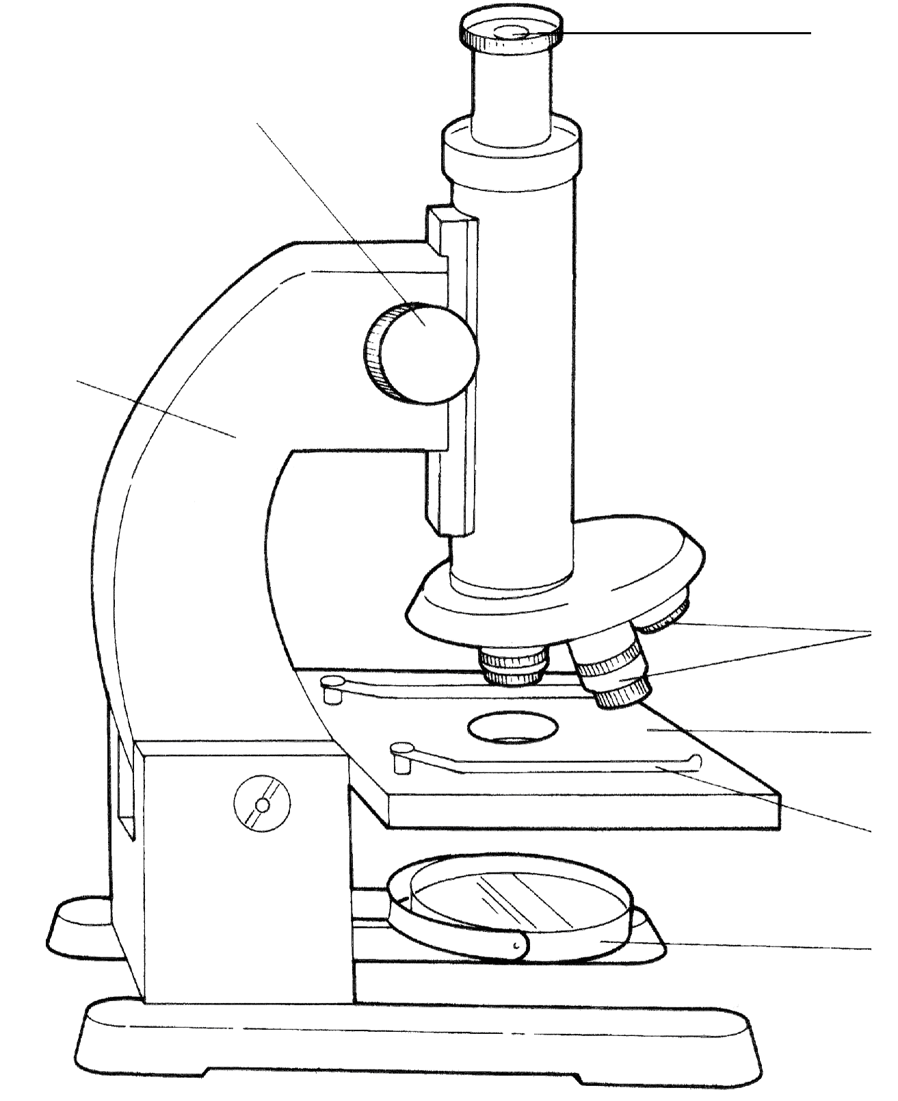

- When viewing objects start with the low power objective lens first.
- This ensures you can locate the object
- It also prevents damage to the objective lens.

Using the microscope questions

Use the information on page 5 of the CCEA GCSE Biology textbook to answer the following in your notebook.
- Which objective lens would you use to find a cell on a slide?
- How would you focus a slide using this lens?
- Which objective lens would you use to observe a cell in detail?
- How would you focus an image using this lens?
- Why is it necessary to use the low power lens rather than the high power lens to view cells initially?

____________________________________________________________________________________________________________________________________________________________________________________________________________________________________________________________________________________________________________________________________________________________________________________________________________________________________
____________________________________________________________________________________________________________________________________________________________________________________________________________________________________________________________________________________________________________________________________________________________________________________________________________________________________
____________________________________________________________________________________________________________________________________________________________________________________________________________________________________________________________________________________________________________________________________________________________________________________________________________________________________
__________________________________________________________________________________________________________________________________________________________________________________________________________________________________________________________________________________________________________________________________________________________________________________________________________________________________________________________________________________________________________
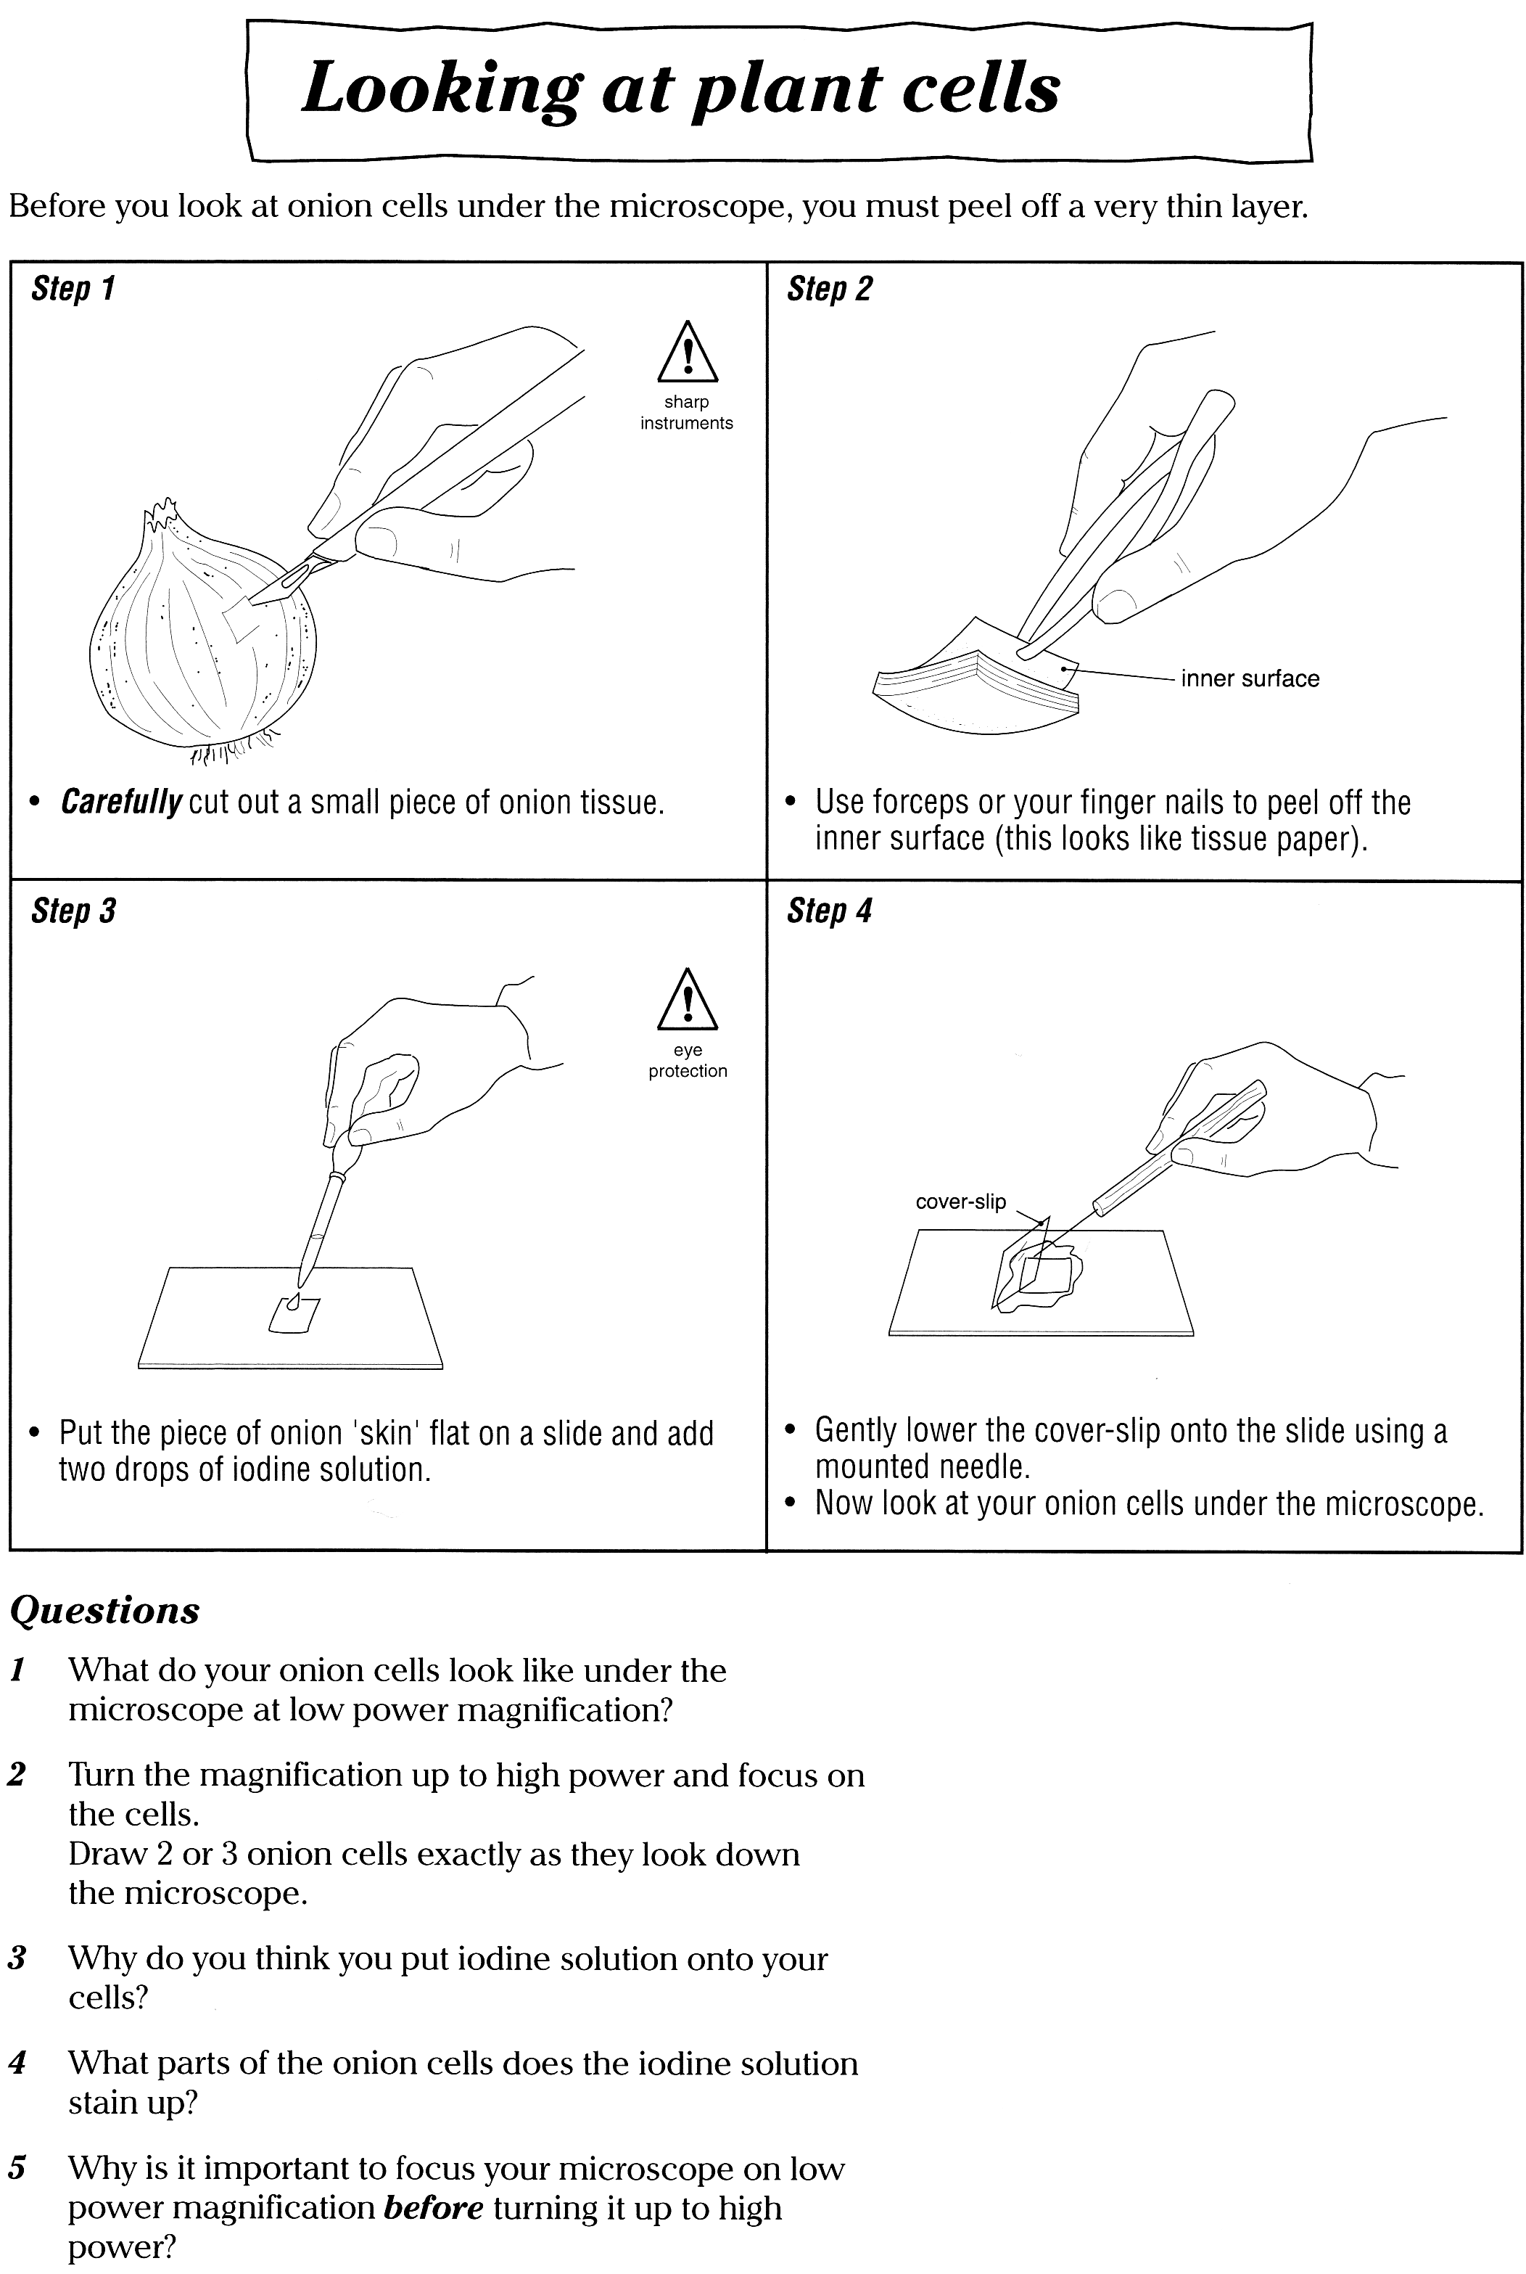

This will allow light to pass through the tissue so you can see the individual cells.

This is the extent to which an object has been enlarged.
To find the magnification from a microscope

A nerve cell viewed using the X4 objective lens and X10 eyepiece will be magnified X40 (4X10).
Using X10 objective lens and same eyepiece they will be magnified X100 (10 X 10).

1m = 1000mm
1mm = 1000μm
1m = 1000 000μm


SIZE MATTERS!

 | SIZE
OBJECT | METRES (m) | MILLIMETRES (mm) | MICROMETRES (μm)
Plant Cell | 0.0001
Red Blood Cell | 0.000008
Bacterial Cell |  | 0.0006
Hair |  | 0.15
Chloroplast |  |  | 10
Measles Virus |  |  | 0.2

USING AN IMAGE TO FIND MAGNIFICATION AND MEASUREMENT

I = image size (size on the picture you are viewing)
I
A = actual size (real size of object)
M = magnification
A
M
YOU MUST KNOW THESE EQUATIONS

I = AxM
A = I/M
REMEMBER!

M = I /A

- Make sure all measurements are converted to the same unit ,
i.e. μm, before you start each calculation.
- Include units in your working out.
- Make sure you give the answer in the correct unit-
Image and Actual are lengths in μm and Magnification doesn’t have a unit.

calculations

1. A cell measures 20 μm in length. When it is magnified using a microscope the image measures 3.6 mm. What is the magnification used?

- Actual size of cell: A = ________________________________
- Magnified size of cell: I = ________________________________
- Convert mm into μm I = ________________________________
- Calculate Magnification (M = I/A): M = ________________________________

2. The bacterium E. coli is a rod shaped microorganism that lives in the human gut. It has a length of 2μm. Calculate its IMAGE SIZE when magnified X600.

- Actual size: A = ___________________________________________
- Magnification: M = ___________________________________________
- SIZE (I = MXA): I = ___________________________________________
___________________________________________
___________________________________________

3. Calculate the ACTUAL SIZE of red blood cell A in the photograph below
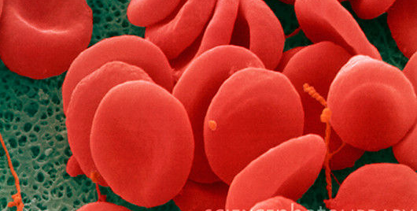
A
X30000

- Measure cell A: I = _________________________________
- Convert mm into μm: I = _________________________________
- You are given the Magnification: M = _________________________________
- Calculate ACTUAL SIZE (A=I/M): A = _________________________________

Calculating magnification using the scale bar:

- If a scale bar is present on a photomicrograph then you can measure it instead of a part of the picture. The length of the scale bar on the ruler is the “Image size” (measure in mm) and the “actual size/length” of it should be written under it.
- We now must convert our mm to micrometres to make sure the units are the same
- Therefore using our triangle (magnification = image size / actual size), we can work out the magnification of that photomicrograph!

1. Calculate the MAGNIFICATION of the plant cell below using a scale bar
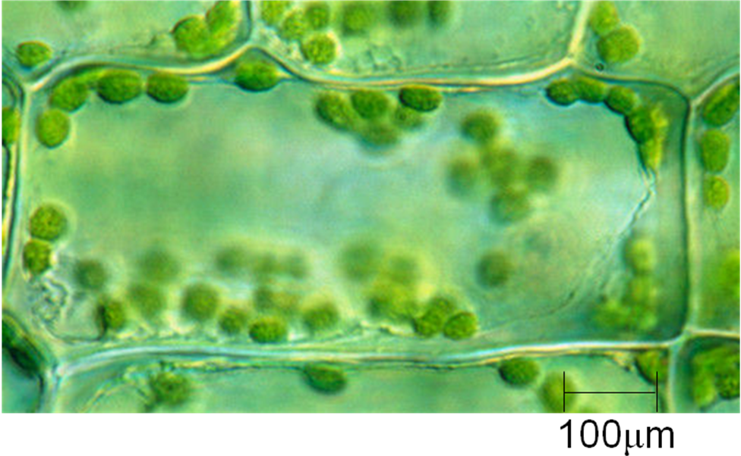
- Read scale bar: A = ________________________________
- Measure scale bar: I = ________________________________
- Convert mm into μm I = ________________________________
- Calculate Magnification (M = I/A): M = ________________________________

2. Use the scale bar to find the magnification of the animal cell in the micrograph below.
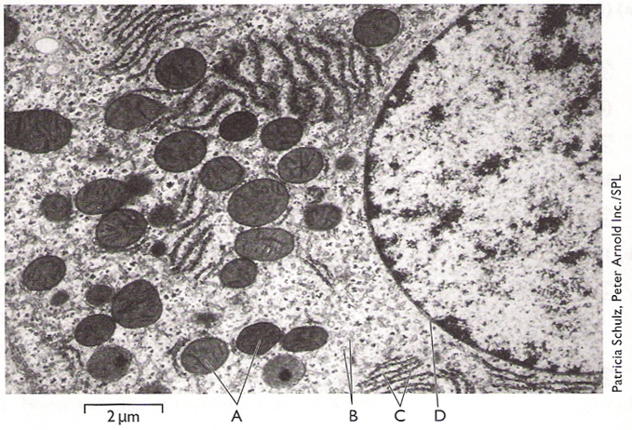

- Read scale bar: A = ___________________________
- Convert mm into μm: A = ___________________________
- Measure scale bar: I = ___________________________
- Convert mm into μm: I = ___________________________
- Calculate Magnification (M = I/A): M = ___________________________
HOMEWORK
Measuring cells

- Suppose that a microscope has two objective lenses (x 10 and x 40) and two alternative eyepieces (x 6 and x 10). What are the four different magnifications which this microscope can achieve?

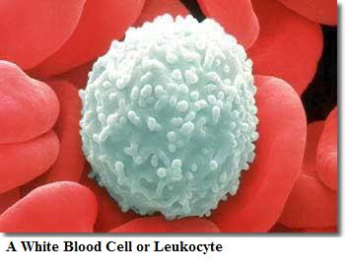
2.
This white blood cell has been magnified X 400.
Calculate its actual width.

- Use the scale bar to calculate the magnification of the cheek cell in the photograph.
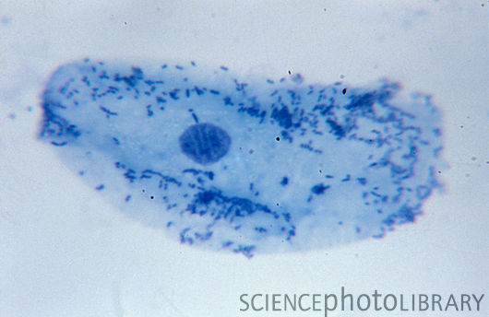
0.01 mm

Sort the cards into the correct order and write the flow chart into the space below.

Organisms which are multi-cellular must have specialised tissues, organs and organ systems. It helps them to:

- exchange substances with the environment
- transport substances within their body
- communicate between cells

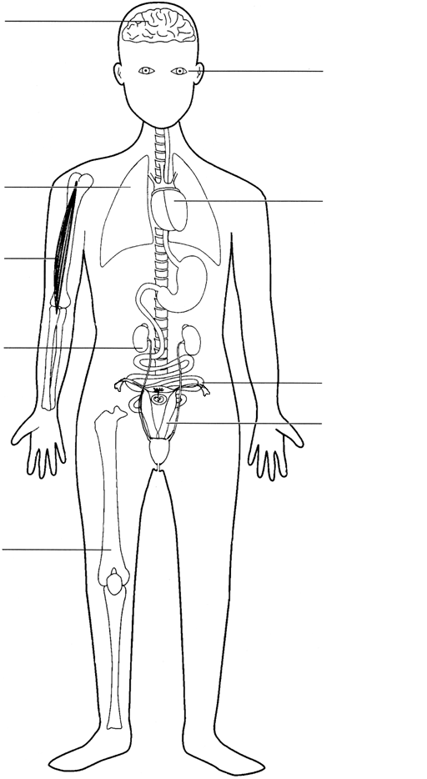

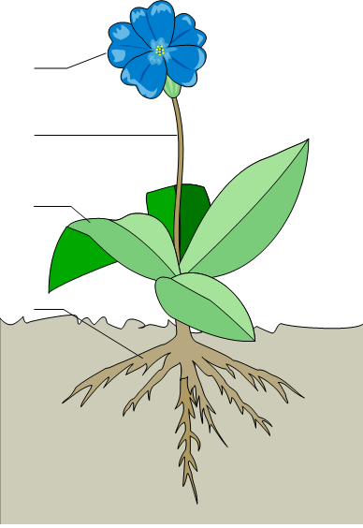

Growth is a permanent increase in size.
This can be because individual cells get bigger, or because cells divide to form more new cells.

Plants and animals grow in different ways.

Most animal cells in an organism can reproduce to form new cells. This results in growth occurring all over the organism’s body giving a rounded shape.

In plants growth is restricted to the tips of roots and shoots. These areas are called apices. This causes plants to grow in a branching pattern.

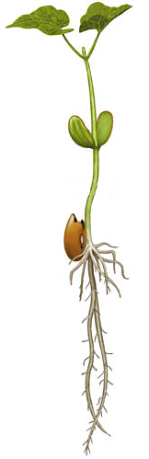

Transport in and out of cells
Body cells need OXYGEN and GLUCOSE to release energy in the process of cell respiration. They also need nutrients such as amino acids, fats, vitamins and minerals for healthy growth. Waste materials such as CARBON DIOXIDE and WATER must also be removed.
Plants also need CARBON DIOXIDE and WATER to make glucose during photosynthesis and need to remove excess OXYGEN

- diffusion
- osmosis
- active transport

the movement of particles from an area of high concentration to an area of low concentration
until they are evenly distributed.
Diffusion is important in the movement of gases in and out of cells

Diffusion in animals
RBC

When the cell respires it uses up oxygen. Blood brings red blood cells carrying lots of oxygen to the body cells. Oxygen moves from a high concentration in the blood to a low concentration in the body cells by diffusion.

RBC

When the cell respires it makes carbon dioxide. Carbon dioxide moves from a high concentration in the body cells to a low concentration in the blood by diffusion. The blood carries the carbon dioxide away. This maintains a concentration gradient for movement of carbon dioxide.

HOMEWORK Diffusion in an alveolus

Diffusion in plants

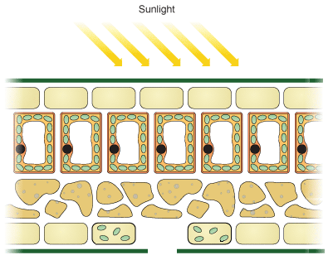

A stem cell is a cell that can divide into any type of cell, it is not specialised
All animal cells originate from embryo stem cells. During the development of an embryo, most of these cells become specialised. They cannot later change to become a different type of cell. This process is called cell differentiation.
Adult stem cells are found in organisms at all stages of their lives, not just adults. They are restricted to develop into the types of tissues in which they are found e.g. skin, blood & bone marrow stem cells.

Collection of stem cells:

- Embryonic stem cells can be removed from human embryos that are a few days old, for example, from unused embryos left over from fertility treatment.

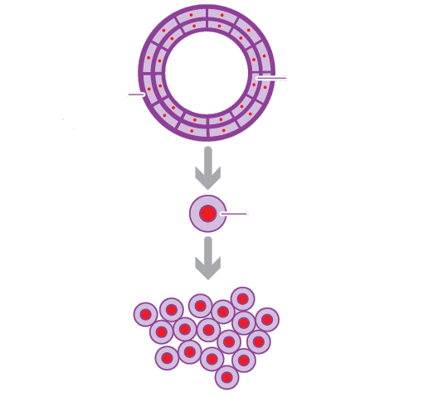

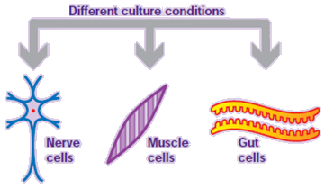

- Adult stem cells can also be collected from skin or bone marrow tissue.

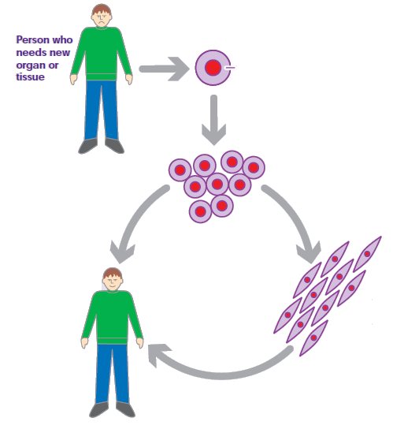

Uses of stem cells

Stem cells can be used for:
  - Growing tissue
  - making new brain cells to treat Parkinson’s disease
  - rebuilding skin, bones and cartilage
  - repairing damaged immune systems
  - making replacement heart valves

  - Growing organs
  - growing trachea

Ethics are the principals by which we live.

- Removing cells from an embryo that could grow into a new individual, even if that embryo has been produced by IVF and is no longer required, is opposed for religious reason.
- The embryo is killed and will not develop into a human.
- Embryo has human rights

Stem cell research is under strict control in most countries. This involves:
- The need for government control of this research to protect the public
- The need for validation of this research by peer review (review by other researchers working on stem cell research)

Advantages of using embryonic stem cells over adult stem cells

- Easier to grow or culture
- More plentiful and easier to extract
- Can develop into a wider range of different cell types and tissues
- There are more in the placenta and umbilical cord than in adult bone marrow



